<http://www.aichengxu.com/design/5740677.htm>

**build.gradle(Project) 和 build.gradle(Module) 的区别**

2016-03-14 15:48 本站整理 浏览(56)

参考：   
　　<http://stackoverflow.com/questions/28295933/difference-between-build-gradleproject-and-build-gradlemodule>  
在Gradle Scripts下有两个build.gradle ，如下图中的build.gradle(Project:Leaks)和build.gradle(Module:app)  
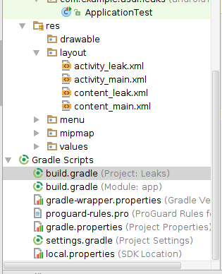  
build.gradle(Project:Leaks)

　　Top-level build file where you can add configuration options common to all sub-projects/modules.

**Each project contains a**

top-level gradle file

. It usally contains

common configs

for all

modules

. Whatever is included in this

top-level gradle

, it will affect all

modules

.  
　　它是顶级配置文件，包含全局配置。在这个文件里的配置项被展开到model下的guild.gradle中。  
build.gradle(Module:app)

　　Build file of your specific module (where you add your dependencies, signing configs, build types, flavors, etc)

　　All modules have a specific gradle file. Whatever is included in this gradle file, it will only affect the module that is included on.  
　　它是局部配置文件，这个文件中的配置项只在引用它的模块中有作用。  
　　注意：一般加引用库时在module的build.gradle中加。